VIBRATIONAL ANALYSIS ON ELECTRICL MACHINES
A PROJECT REPORT

Submitted by
ABHAYA.V.NAIR EPAOEEC001
AMEENA.A.K EPAOEEC008
ATHIRA.P.S EPAOEEC018
BHAVYALAKSHMI.C.S EPAOEEC021
SNEHA SASI EPAOEEC051

ACKNOWLEDGEMENT

We hereby take this opportunity to thank all those who helped us to make this project a success. We thank lord Almighty for his blessings during the execution phase of this project. This project could not have been done properly without the help and encouragement from various people.
First and foremost, we would like to express our heartfelt thanks to our principal Dr. P. C. Reghu raj, the leading light of our institution. We would like to thank Dr. A. R. JAYAN, Head of the department, Electronics and communication Engineering. We would also like to thank our guide Associate Prof. Mr. ANOOP C. S. It was by his support we got proper guidance for completing the project. Also we express our gratitude to all faculty members and supporting staff of the department for the help and support given to us.
Also we take this opportunity to thank our friends for their ideas, suggestions and co-operation and our beloved parents, for their support and encouragement throughout this project.

ABSTRACT
The purpose of this project is to demonstrate the importance of vibration measurement in modern day motors or electrical machines. In electric machines like motors, transformers, etc. produces vibration in running condition. Due to hysteresis and mechanical movement, it may affect the smoothness of machine. Our aim is to monitor the vibration and reduce the failure rate of electrical machines.
The vibration monitoring can help to prevent wear in motors thereby increasing its efficiency and lowering the maintenance cost. Early fault detection is needed for protection of motor. Through knowledge and accurate diagnostic procedures, it is possible to detect the cause of vibration. The sensor is positioned on the electrical machines. Under abnormal conditions during the working of machines, the vibration pattern gets changed. Amount of variation can be detected and the nature of abnormalities can be analyzed with MATLAB to get an idea about the fault in the machine. Based on the defect predictive maintenance schedule can be proposed.

CHAPTER 1
INTRODUCTION
Vibration from a motor or machine contain vital information about the operation state and condition of the machine. Analysis and categorizing of various vibration pattern provide us with a visual reference to critical situation which may damage the system. By analyzing vibration along with current, we propose to develop an electronic control system capable for predicting faults which in turn will help to save valuable resources.
Today electricity is widely used to power up appliances from homes to industries. Our special interest is on industrial equipments which are powered by an electrical motor. Power output from motor is coupled to the shaft of machine. Coupling components include shafts, gears, belts and bearings essentially transferring energy. Even though these components are designed for high performance and rigidity with time they start to develop flaws. High frequency of operation causes bearings and components to reach the end of their product life. Hence with increasing use or age, the machines begin to vibrate more distinctly producing abnormal movements which reduces overall efficiency. Such vibrations are caused by imbalances in the rotating parts, uneven friction, meshing & wear and tear of gear teeth or bearing, rotor etc. Traditional maintenance methods are preventive in nature, i.e. components are replaced on a fixed schedule irrespective of whether they are worn out or not. Another approach is being reactive , and repair the components only after they are broken down.
Predictive maintenance can be achieved by vibration analysis. The vibration of machine assembly or specific part are recorded using sensors, such as accelerometer. These recorded vibrations are analyzed to estimate how much more time the part could work, without any issues. We can have a visualization and estimation about working state of the machine by means of vibration.
Therefore predictive maintenance using vibration analysis ensures the quality of components in operating machines. If any fault occurs in components, continuous vibration analysis can detect possible fault and respective corrective action can be taken to keep system in operation. Hence vibration analysis provides faster, continuous and efficient fault detection.

PROPOSED WORK

FIG.1. Proposed work

VIBRATION
Vibration may be defined as the oscillatory or cyclic motion of a solid body, about some equilibrium point when excited by an appropriate force. The equilibrium position is the position which an object will attain when the force acting on it is zero. This type of vibration is called “whole body motion” i.e. all parts of the body are moving together in the same direction at any point of time.
Most engineering machines & structures experience vibration to some degree & their design generally requires consideration of their oscillatory behaviour. The vibration of an object is always caused by an excitation force which may be externally applied to that object or it may originate inside the object.
The vibration/ oscillatory motion of the system may be objectionable or desirable depending on the purpose of the machine. The objective of the designer is to control or minimize the vibration when it is objectionable and to utilize and enhance it, when it is desirable.
The objectionable vibration in a device may cause fatigue, failure, the loosening of parts, malfunctioning, imbalances in the rotating parts, uneven friction, meshing, wear and tear of gear teeth or bearings, rotor or eventual failure of the mechanical system.
Vibrations are characterized by two specific features. These are :
- Amplitude of vibration
- The frequency of vibration, where f=1/T

The amplitude tell us how bad it is vibrating. The frequency tell us what is vibrating.

Classification of vibrations
Vibration can be classified in various ways. This classification depends on the behaviour of physical system under study as well as the nature of the dynamic forces acting on the system and the response of the system to these loads. Oscillatory system can be characterized as linear and non linear.
Classification of vibration can also be based on the nature and behaviour of input to the system and the corresponding response. There are two general classes of vibration in this regard - free and forced vibration. If the system is excited by an external force, the resulting vibration is called forced vibration. e.g. the oscillation that arises in a machine such as rotating shaft due to unbalance, is forced vibration.
Free vibration take place when a system oscillates under the action of force inherent in the system itself & when after an initial disturbance, the system is left to vibration its own and no external force acts on the system.
When the excitation is oscillatory, the system is forced to vibrate at the excitation frequency. If the frequency coincide with one of the natural frequencies of the system, a condition of resonance occurs & the system undergoes dangerous large oscillations. Vibration is also classified as deterministic or random.
If the magnitude of the excitation acting on a vibratory system varies in accordance with a prescribed function at any given time, the excitation of deterministic. The resulting vibration is known as deterministic vibration.
In some case the excitation is non deterministic or random, i.e. the value of excitation at any given time cannot be predicted. This defines the class of vibration called random vibration.

Sources of vibration
Vibrations results from dynamic forces which produce a series motion within system. These motions may be linear or nonlinear or combination of both of these. Machinery vibrations can be measured and analyzed to provide a cost effective, predictive method of diagnosing the cause for development of failure conditions. Typical machinery faults which may be discovered by vibration analysis are:
- Absence of lubrications
- Bent shafts.
- Damaged or misaligned devices.
- Damaged bearings.
- Eccentricity.
- Fretting corrosion.
- Incorrect assembly.
- Insecure components.
- Mechanical slackness.
- Onset of cavitations.
- Presence of solid bodies.
- Static or dynamic unbalance.
- Worn bearings.
- Warn or damaged gears.

CHAPTER 2
BLOCK DIAGRAM
For detecting faults in a machine, the vibrations are recorded by an accelerometer and PIC microcontroller. The values are displayed on LCD monitor (Keys and display are used for user interface). The recorded vibrations are then analyzed by PC using MATLAB. Main aim of our project is to provide predictive maintenance approach for machines.

FIG.2. Block diagram
Block diagram consists of
- AC Power Supply
Such power supplies will sometimes employ a transformer to convert the input voltage to a higher or lower AC voltage. A rectifier is used to convert the transformer output voltage to a varying DC voltage, which in turn is passed through an electronic filter to convert it to an unregulated DC voltage.

- Voltage regulator
A voltage regulator is an electronic circuit that provides a stable dc voltage independent of the load current, temperature and ac line voltage variations. A voltage regulator may use a simple feed-forward design or may include negative feedback. Depending on the design, it may be used to regulate one or more AC or DC voltages. Here we use 7805 voltage regulator, which is used for regulate the AC voltage at 5V.
- MEMS Accelerometer
MEMS stand for Micro Electro Mechanical System. We are using MEMS sensor because of small size, low power and high level of functionality. It offers easy integration and reduces cost to emerging group of new users. The objective is to correlate observable vibrations with typical wear out mechanisms, such as bearings, gears, chains, belts ,brushes, shafts, coils and valves. Here we use ADXL335 Accelerometer.
- PIC Microcontroller
PIC (usually pronounced as "pick") is a family of microcontrollers made by Microchip Technology, derived from the PIC1650 originally developed by General Instrument's Microelectronics Division. The name PIC initially referred to Peripheral Interface Controller.
- LCD
The user interface will provide ability to setup the device and see real time output.
- USB Adapter
A USB adapter is a type of protocol converter which is used for converting USB data signals to and from other communications standards. Commonly, USB adaptors are used to convert USB data to standard serial port data and vice versa. Most commonly the USB data signals are converted to either RS232, RS485, RS422, or TTL-level UART serial data.

WORK FLOW
- Phase 1- Studying Vibration pattern.
In his phase, we will obtain vibrations patterns from the machine under observation. For this part , we will get started with MEMS accelerometer and record the signal in PC. By using PYTHON Software, we will develop an algorithm to store the vibrations occurrences by developing a database.
- Phase 2 – Hardware Estimation.
This phase is critical towards designing actual hardware and estimating cost. We will choose a microcontroller from PIC microcontroller having higher sampling rate so as to collect all frequency components. Then the algorithm is developed in PYTHON for storing the vibrations in PC.
- Phase 3- Hardware development
In this stage, we will prepare circuit layout and PCB for mounting the circuit. Once board is ready, code for microcontroller will be developed. We use MPLAB IDE for developing and evaluating the codes for PIC microcontroller.

CHAPTER 3
HARDWARE DEVELOPMENT
3.1. ACCELEROMETER
Accelerometer is a transducer that measures acceleration. It measures relative “weight” experienced by test mass. Piezoelectric crystal is basic accelerometer. MEMS accelerometers are available which provides better resolution . MEMS accelerometers are available in Multi-Axis models ( 2or 3). They can directly provide digital SPI output or Analog output.
Piezoelectric accelerometer which was initially used to capture the signal. The piezoelectric accelerometer can be considered the primitive vibration transducer for machine vibration measurement.
The output of the accelerometer is plugged to LCD for user interface. Output is basically voltage which varies in accordance with vibration pattern of machine.
ADXL335
The ADXL335 is a small, thin, low power, complete 3-axis accelerometer with signal conditioned voltage outputs. The product measures acceleration with a minimum full-scale range +_ 3g. It can measure the static acceleration of gravity in tilt sensing application, as well as dynamic acceleration resulting from motion, shock, or vibration.
Features:-
- 3-axis sensing
- Small, low profile package
- 4 mm × 4 mm × 1.45 mm LFCSP
- Low power : 350 μA (typical)
- Single-supply operation: 1.8 V to 3.6 V
- 10,000 g shock survival
- Excellent temperature stability
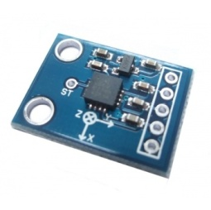

FIG.3 ADXL335
3.2. PIC MICROCONTROLLER
PIC (usually pronounced as "pick") is a family of microcontrollers made by Microchip Technology, derived from the PIC1650 originally developed by General Instrument's Microelectronics Division. The name PIC initially referred to Peripheral Interface Controller.
Early models of PIC had read-only memory (ROM) or field-programmable EPROM for program storage, some with provision for erasing memory. All current models use flash memory for program storage, and newer models allow the PIC to reprogram itself. Program memory and data memory are separated. Data memory is 8-bit, 16-bit, and, in latest models, 32-bit wide. Program instructions vary in bit-count by family of PIC, and may be 12, 14, 16, or 24 bits long. The instruction set also varies by model, with more powerful chips adding instructions for digital signal processing functions.
The hardware capabilities of PIC devices range from 6-pin SMD, 8-pin DIP chips up to 144-pin SMD chips, with discrete I/O pins, ADC and DAC modules, and communications ports such as UART, I2C, CAN, and even USB. Low-power and high-speed variations exist for many types.
- 16F877A
PIC16F877A, a CMOS FLASH based 8 bit microcontroller packs Microchip powerful PIC’s architecture into an 40 or 44 pin package and is upwards compatible with the PIC16C5X, PIC12CXXX and PIC16C7X devices. The PIC16F877A features 256 bytes of EEPROM data memory, self programming, an ICD, 2 Comparators, 8 channels of 10-bit Analog-to-Digital (A/D) converter, 2 capture/compare/PWM functions, the synchronous serial port can be configured as either 3-wire Serial Peripheral Interface (SPI) or the 2-wire Inter-Integrated Circuit bus and a Universal Asynchronous Receiver Transmitter (USART).
PIC16F877A Features
- 2 PWM 10-bit
- 256 Bytes EEPROM data memory
- ICD
- 25mA sink/source per I/O
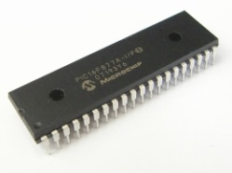
- Self Programming
- Parallel Slave Port

FIG.5. PIC 16F877A
3.3 LIQUID CRYSTAL DISPLAY
LCD (Liquid Crystal Display) screen is an electronic display module and find a wide range of applications. A 16x2 LCD display is very basic module and is very commonly used in various devices and circuits. These modules are preferred over seven segments and other multi segment LEDs. The reasons being: LCDs are economical; easily programmable; have no limitation of displaying special & even custom characters (unlike in seven segments), animations and so on.
A 16x2 LCD means it can display 16 characters per line and there are 2 such lines. In this LCD each character is displayed in 5x7 pixel matrix. This LCD has two registers, namely, Command and Data.
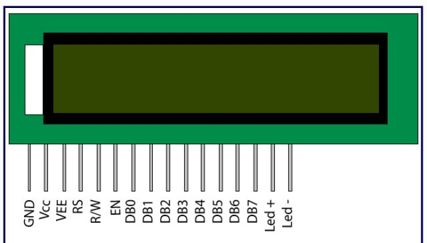
FIG.6. Liquid Crystal Display
3.4 USB TTL converter
The USB TTL Serial cables are a range of USB to serial converter cables which provide connectivity between USB and serial UART interfaces. A range of cables are available offering connectivity at 5V, 3.3V or user specified signal levels with various connector interfaces. Currently, USB to TTL-level UART converters are used extensively by students and hobbyist as they can be directly interfaced to microcontroller.
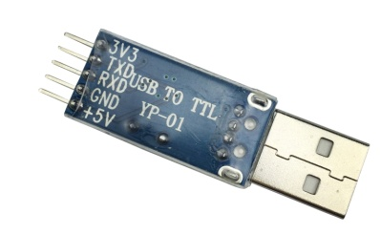
FIG.7. USB to serial converter

HARDWARE DESCRIPTION
The main part of the vibration measurement system of electrical machine is 16F877A PIC Microcontroller. This microcontroller is connected to the MEMS Accelerometer sensor which will give the acceleration in ‘g’. The microcontroller also get interfaced to LCD which will display the vibration(acceleration). The vibrations & corresponding graph is stored in PC with the help of a serial communication interface. Vibration in X-axis(blue), Y-axis(green), Z-axis (red) of electrical machine are plotted against time.
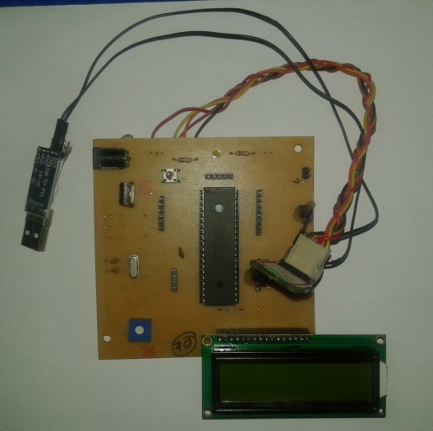
FIG.8.HARDWARE
PCB LAYOUT
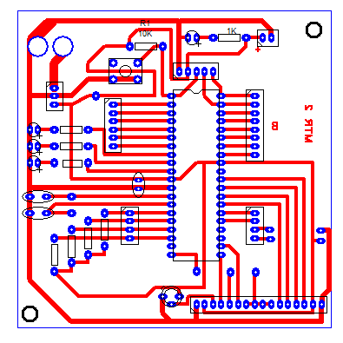
FIG.9.PCB LAYOUT

CHAPTER 4
SOFTWARE DEVELOPMENT
4.1.MPLAB IDE
Here we are using Hi-Tech C Compiler library for MPLAB.
1. Download and Install MPLAB IDE with Hi-Tech C compiler
2. Open MPLAB IDE
3. Click on Project >> project Wizard
FIG.10.
4. Click on Next

FIG.11

5. Select PIC16F877A and click Next
FIG.12.
6. Select Hi-tech C compiler and click Next
FIG.13

7. Select Project path, give a file name and click Next
FIG.14.
8. Add required files to Project (if necessary) and click Next
FIG.15

9. Click Finish to complete project creation 10. Go to File-New
Then we can start to write our corresponding program code and save as a c file (*.c). In code we can add library and we need to define the oscillator used in the system (oscillator frequency).TRIS is the command used for initializing the ports of the microcontroller.
- Add this c file to source group .Right click on source file >> Add files
- Build the project to generate hex file. Click on Project >>Build
FIG.16.
If it build successful then there is no error otherwise correct the error and build it again. Then next step is to stimulate the program using proteus. Open proteus and draw the circuit, then next step is to burn the program into the PIC microcontroller by double clicking the PIC. Then a dialog box will appears where we have to enter the oscillator frequency and export the corresponding hex file.

4.2 PROTEUS 8 PROFESSIONAL
Proteus Virtual System Modeling (VSM) software offers the ability to co-simulate both high and low-level micro-controller code in the context of a mixed-mode SPICE circuit simulation. It combines mixed mode SPICE circuit simulation, animated components and microprocessor models to facilitate co-simulation of complete micro-controller based designs. With VSM, it is possible to develop and test such designs before a physical prototype is constructed. The designer can interact with the design using on screen indicators such as LED and LCD displays and actuators such as switches and buttons. The simulation takes place in real time

4.3 IDLE (PYTHON 3.6-64 bit)
IDLE is Python’s Integrated Development and Learning Environment. IDLE has two main window types, the Shell window and the Editor window. It is possible to have multiple editor windows simultaneously. Output windows, such as used for Edit / Find in Files, are a subtype of edit window. They currently have the same top menu as Editor windows but a different default title and context menu.
IDLE’s menus dynamically change based on which window is currently selected. Each menu documented below indicates which window type it is associated with.
- Create a new file window
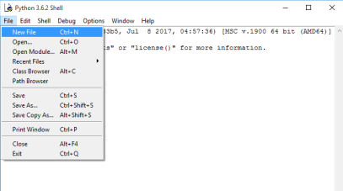
FIG.17
- Write the program in the new window
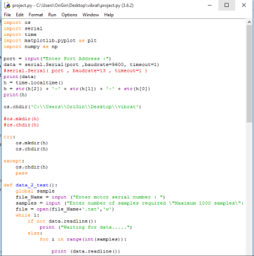
FIG.18
- Run the program (Run >> Run module)
It creates a new window
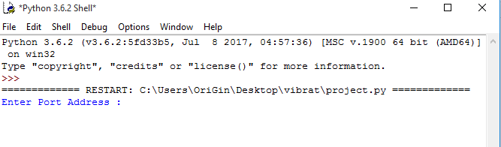
FIG.19
OBSERVATIONS
By running the program we get the vibration in 3-axes and the vibrations are stored in the PC in the form of values(vibration in ‘g’) and graph(plotted vibration against time). For example :
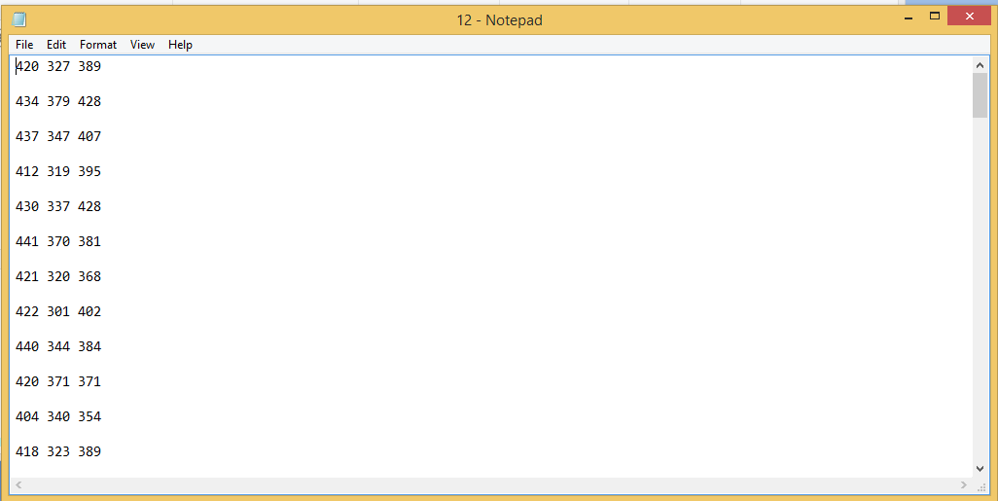
FIG.20.
Plotted vibration
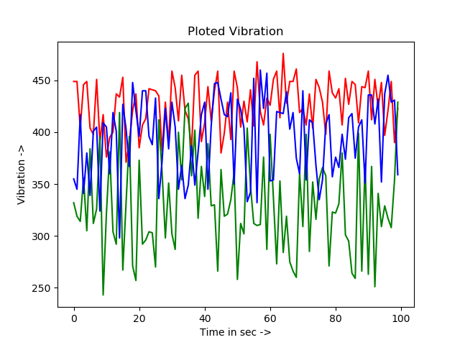
FIG.21

References
1.Vibration Analysis of Electrical Machines. Yogesh Gaidhane Mayur Mankar , Shubham Kherde, Priyanka Salve , Ruchita Kawale, Saily Thaokar .Associate Professor, Department of Electronics and Communication, Dr.Babasaheb Ambedkar College of Engineering and Research, Wanadongri, Nagpur, India U.G. Student, Department of Electronics and Communication, Dr.Babasaheb Ambedkar College of Engineering and Research, Wanadongri, Nagpur, India, IJIRSET 2016.
2. W. Q Lim, D. H Zhang, J. H Zhou, Belgi P. H. and Dr. H. L. Chan, "Vibration-based Fault Diagnostic Platform for Rotary Machines, IEEE 2010, ISBN: 978-1-4244-5226-2, Page(s): 1398-1403.
3.Liu Zhan-feng, Liu Jian-jiang and Zheng Pei, "Study on Engine Vibration Signal Collection Method, " IEEE-2010, ISBN: 978-1-4244-2.
4. S.Nandi and H.A. Toliyat, “ Condition Monitoring And Fault Diagnosis of Electrical Machines- A Review”, in proc, 34th Annual Meeting of the IEEE Industry Applications,pp.197-204,1999.

